**Users in Linux**

* In Linux when we connect via remote session there are no visual interfaces
* Connect to the linux instance

ip: 20.55.19.106

username: experiment

password: experiment

* The command pattern is ssh username@ipaddress
* To create a user adduser <name>  
  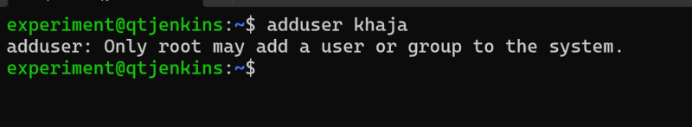
* In Linux if you want to elevate your previleges add sudo infront of your command sudo adduser <name>  
  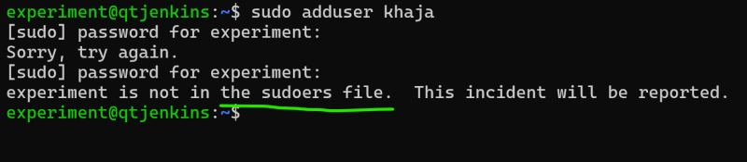
* the user with which you are executing sudo needs to have part of sudoers group

**Shell and Kernel**

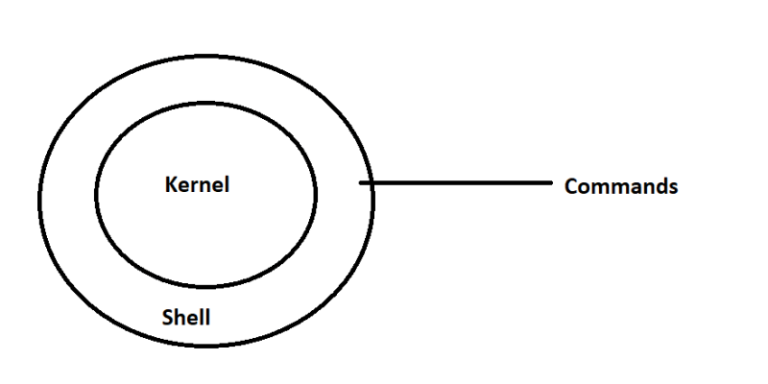

**Distribution**

* Linux Kernel is the Core Operating System in Linux
* Some Organizations like Canonical, SUSE, RedHat etc take the linux kernel add some more applications for better experience. These are referred as distributions.
* Examples of Distribution
  + Redhat
  + Centos
  + Ubuntu
  + Fedora
  + Kali
  + Debian
  + Amazon Linux

**Application Installation**

* Application Installation will copy files into the system.
* To do this we have 3 ways
  + Manually download the files (generally as zip or tar) extract and use
  + Download the installer file/executable and run that
  + Using Package Managers
    - Mac: brew
    - Windows: choco
    - Linux:
      * Ubuntu: apt
      * Redhat: yum